Name | Prathmesh V. Patil
Roll no | 24204C0025
Batch | 02
Subject name | Java Programming
Teacher Name | Ms. Rasika Patil

Experiments | 23
Title | Write program to retrieve hostname and IP address using InetAddress class
Programming Questions with Answer
1 | Write any four differences between IPV4 and IPV6
ANSWER | 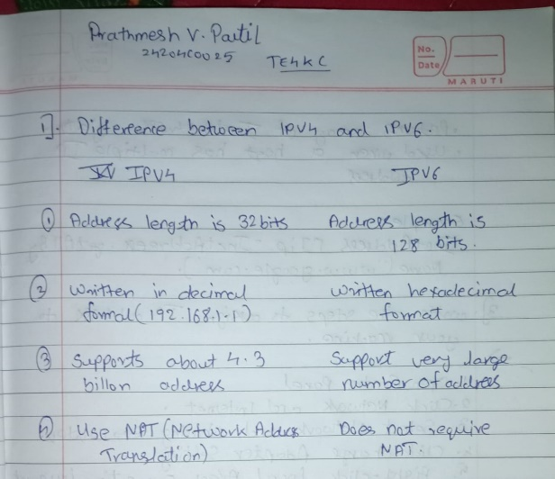
2 | Write the use of getByName() and getAllByName() method.
ANSWER | 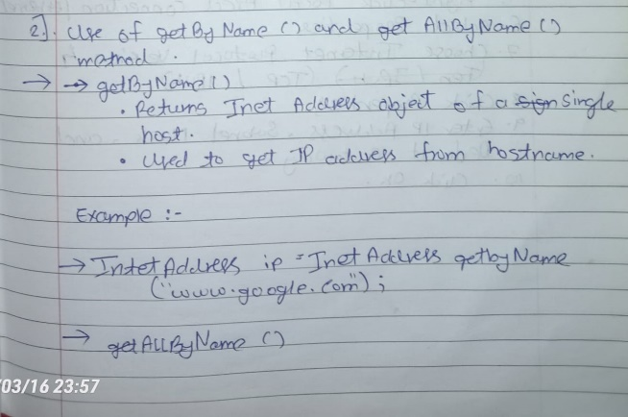  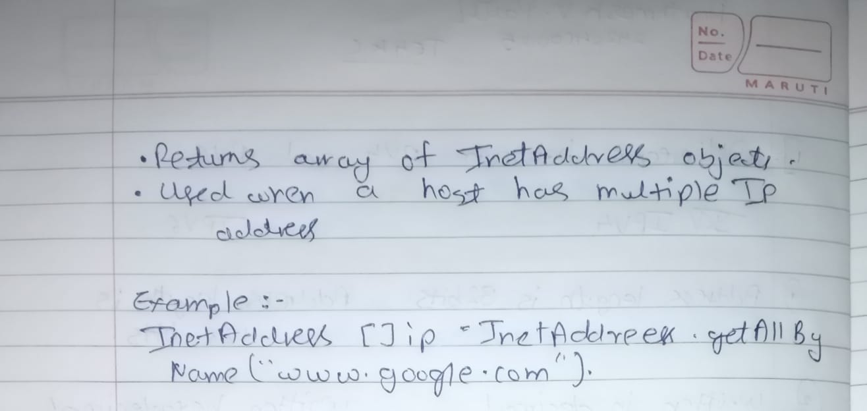
3 | Write the steps to assign IP address to your machine
ANSWER | 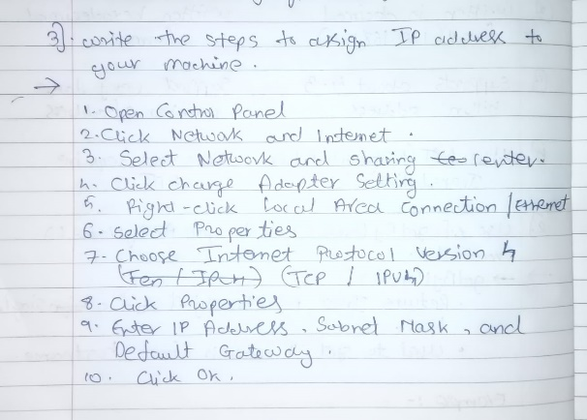
4 | Develop a program using InetAddress class to retrieve IP address of computer when hostname is entered by the user.
ANSWER | import java.net.InetAddress;  import java.util.Scanner;  public class GetIPAddress {  public static void main(String[] args) {  try {  Scanner sc = new Scanner(System.in);  System.out.print("Enter Host Name: ");  String host = sc.nextLine();  InetAddress ip = InetAddress.getByName(host);  System.out.println("IP Address: " + ip.getHostAddress());  } catch (Exception e) {  System.out.println("Invalid Host Name");  }  }  }  OUTPUT:  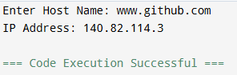
5. | Program to retrieve IP address when hostname is entered by user
ANSWER | import java.net.InetAddress;  import java.util.Scanner;  public class HostToIP {  public static void main(String[] args) {  try {  Scanner sc = new Scanner(System.in);  System.out.print("Enter Hostname: ");  String host = sc.nextLine();  InetAddress ip = InetAddress.getByName(host);  System.out.println("IP Address: " + ip.getHostAddress());  } catch (Exception e) {  System.out.println("Invalid Hostname");  }  }  }
Conclusion | The InetAddress class in Java is used to obtain network information such as the hostname and IP address of a system. Using methods like getHostName() and getHostAddress(), a program can easily retrieve and display this information. This helps in understanding and managing network communication in Java applications.

